Models and Animations

Index
- Simplest Way to transfer models and animations from Blender to Godot
- If you want to use separate files for models and animations

1. Simplest Way to transfer models and animations from Blender to Godot
- Put the model and animations into a single blender file
Use different blender scenes for each animation
- (From Blender) Export your blender file, using “glTF” (left image)
With these settings checked (right image)
Format: Embedded
Remember Export Settings: toggled on (optional, quality of life)
Apply Modifiers: toggled on
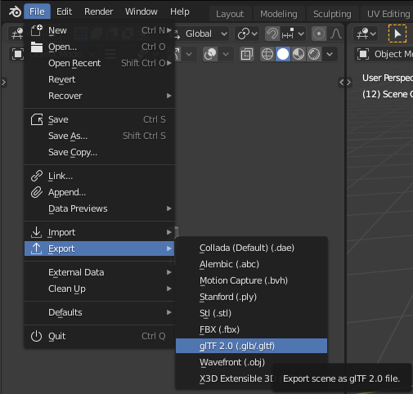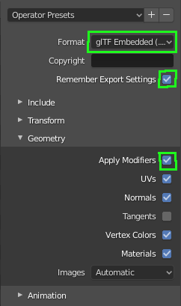
- (In Godot) Use the “FileSystem” to navigate to your blend file
All you have to do now, is drag that file into any of your scenes you want to use it in
or if you want to make an editable (Godot) scene for the model,
right click on the (gltf) file, then in the pop-up menu click "New Inherited Scene”It will pop-up a new scene, save it where you wish.
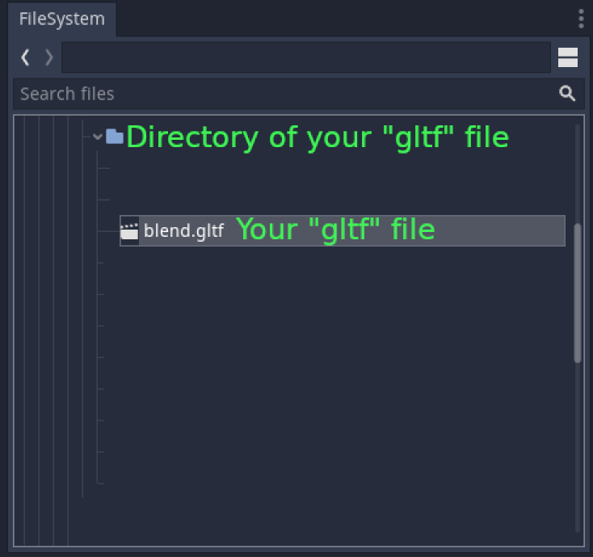 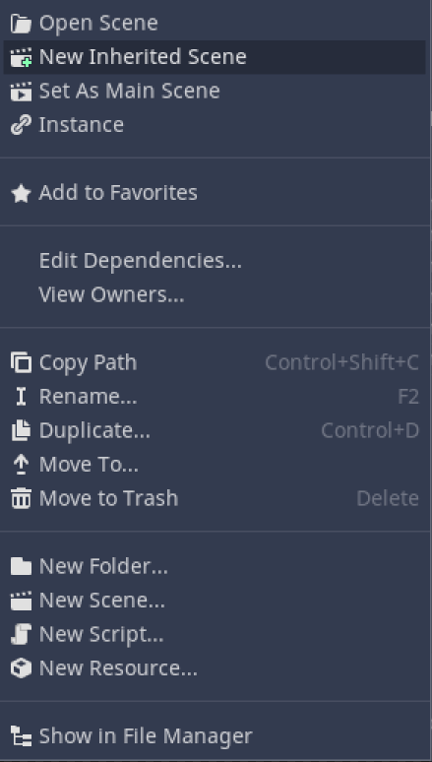

2. If you want to use separate files for models and animations
Obviously this is going to be more difficult.
And there are some quirks.
Here is the simplest way I know, that has worked for me.
Notes before I continue, this method, requires you to essentially duplicate the model, for each animation file, so keep that in mind.
- Create your model
- Create another blender file, this will be the animation file
empty everything out of it
- Append the model file into the animation file
(in blender, change mode to object, then click file→Append, then select your file, then it will show a bunch of folders, go into the “Collections” folder, then select the collection the model belongs to)
- Animate the model
- export using the same export method as in
(1. Simplest Way to transfer models and animations from Blender to Godot)
- (In Godot) (In the “FileSystem” tab) select the animation gltf file, then (in the “Import” tab) change the preset to “Import With Separate Animations”
Re-import, this will create a new (Godot) animation file (.anim file probably) in the same directory as the gltf file, use the (Godot) file for your animation needs
- (If you don’t know how to add it to a Model)
Create an “Inherited Scene” via the method in
(1. Simplest Way to transfer models and animations from Blender to Godot)
then (in the Scene window), select the “AnimationPlayer”
then click the “Animation” box, click load in the pop-up, select your animation file, then click the box next to the Animation box, and (from the pop-up) select the animation you want to view.
And that’s it!
It should all work…
Unless it doesn’t.
If not you might have to change the, path like thing, for the key-frame rows thing, I’m not an animator, but this is what I figured out.
